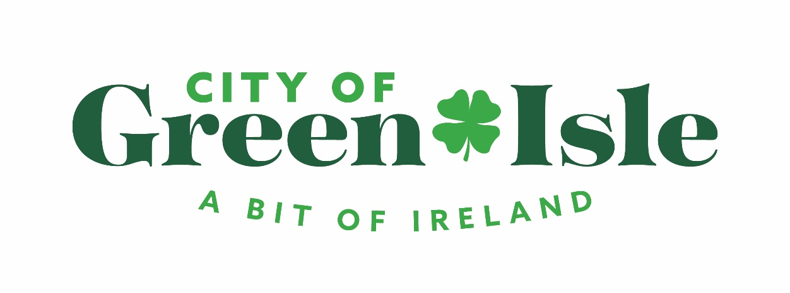

**EDA Meeting Agenda**

Monday, February 6, 2023 7:00 PM

Green Isle City Hall

1. Call Meeting to Order and Pledge of Allegiance
2. Election of Officers

ï. President

1. Vice President
2. Secretary
3. Approve/deny February 7, 2023 Agenda
4. Approve/deny December 6, 2022 minutes, February 2, 2023 Joint EDA/P&Z minutes
5. Bills & Communication: RLF Balance $
6. Monthly Reports/Updates:
   1. Mayor’s Report
   2. Council Liaison Report:
   3. Mark Wentzlaff
   4. Diane Brown (parks)
7. Old Business
   * 1. Comprehensive Plan Update
     2. Music Series update “Clover Leaf Concert Series”
8. New Business
   * 1. Approve/Deny 2022 Annual Report
     2. Inquiry into industrial park lot

8. P&Z Update

9. Board and Director Comments

10. Adjournment